## Practice Activity 5

Name: Zahida

Mail id: [zahidajmi1809@gmail.com](mailto:zahidajmi1809@gmail.com)

User id: 34949

## SCREENSHOTS OF CMDLETS

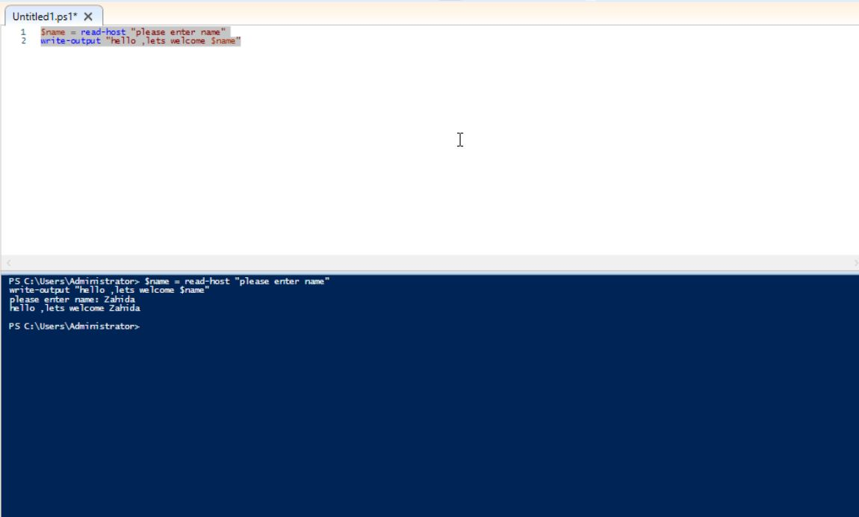

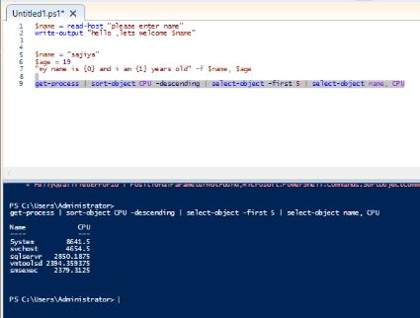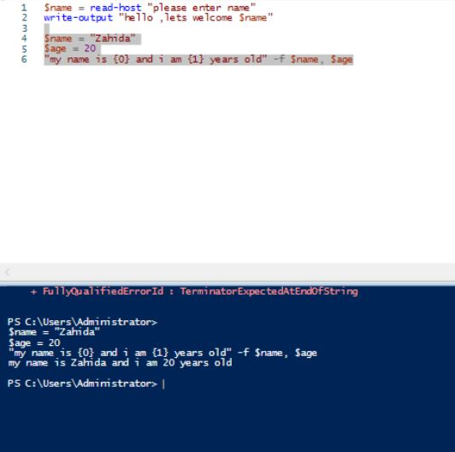

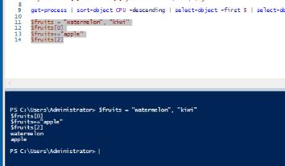

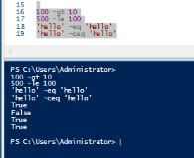

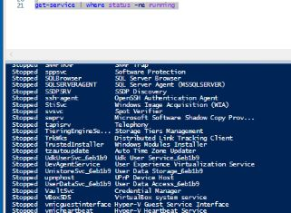

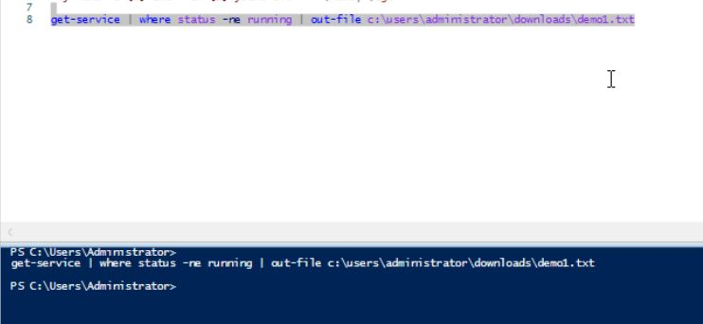

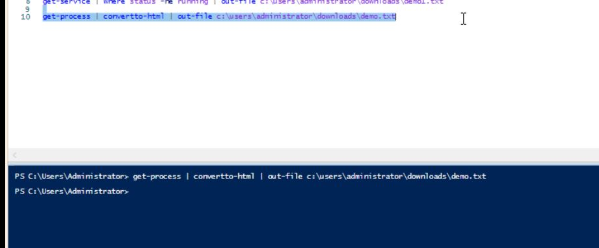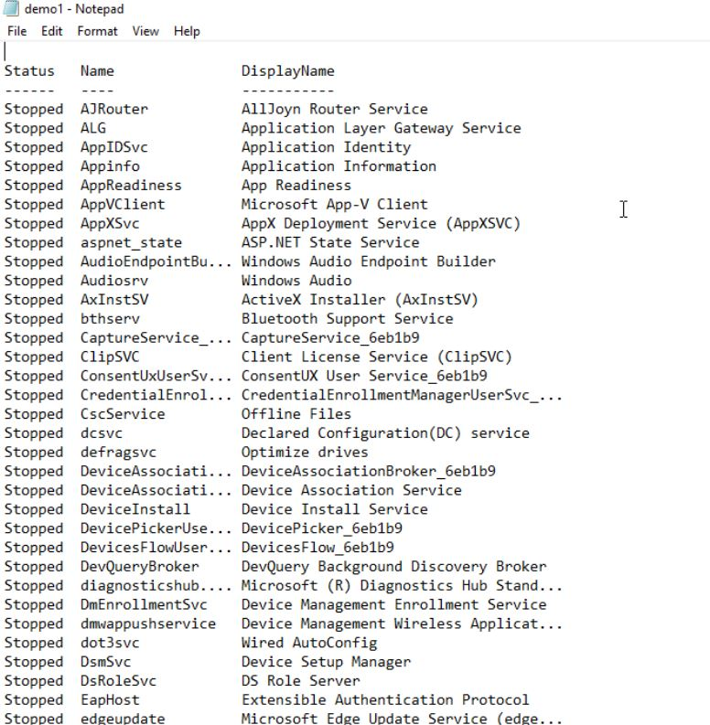

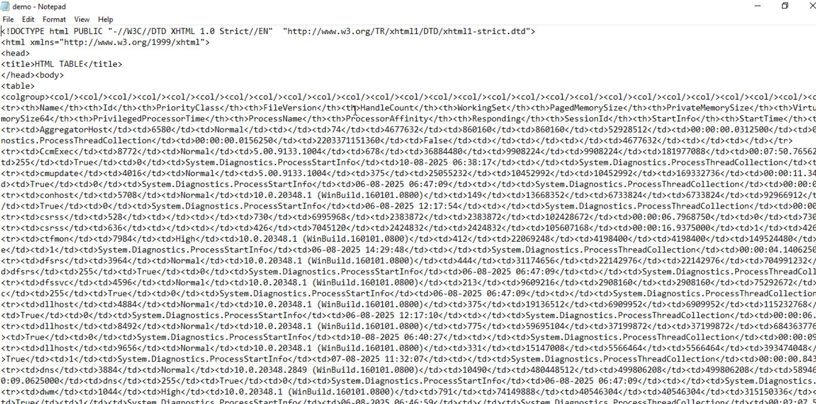

$name = Read-Host "please enter name"

Write-Output "Hello ,lets welcome $name"

$name = "Zahida"

$age = 20

"My name is {0} and I am {1} years old" -f $name, $age

Get-Process | Sort-Object CPU -Descending | Select-Object -First 5 | Select-Object Name, CPU

$fruits = "watermelon","kiwi"

$fruits[0]

$fruits+="apple"

$fruits[2]

100 -gt 10

500 -le 100

'hello' -eq 'HELLO'

'hello' -ceq 'HELLO'

Get-Service | Where status -ne Running

Get-Service | Where status -ne Running | Out-File c:\users\administrator\downloads\demo1.txt -Append

Get-Process | ConvertTo-HTML | Out-File c:\users\administrator\downloads\demo.txt